**Q1:**

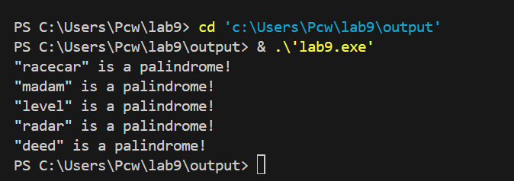

**Q2:**

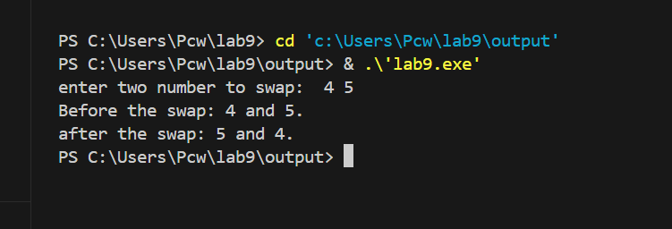

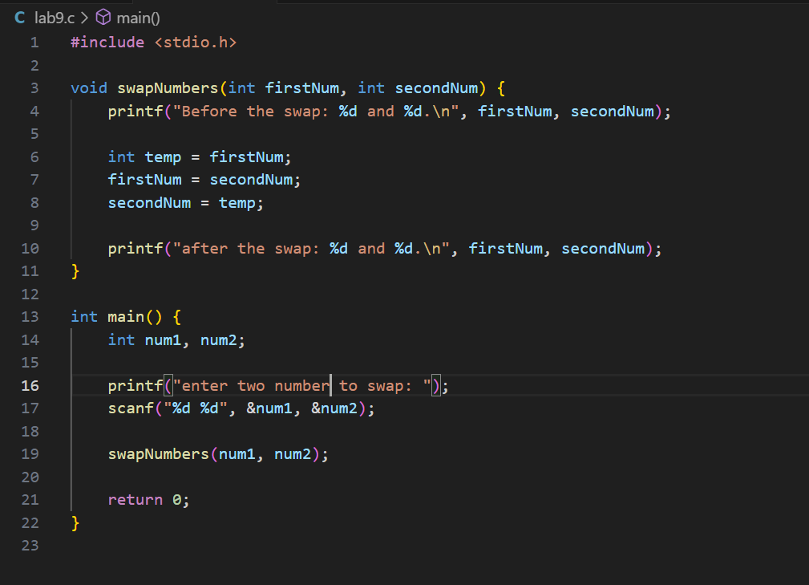

**Q3:**

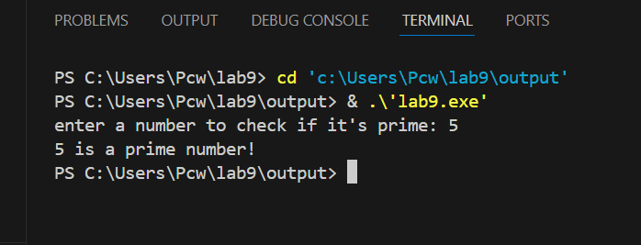

**Q4:**

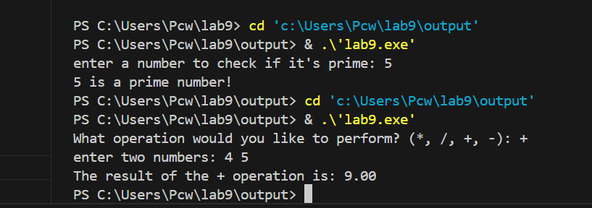

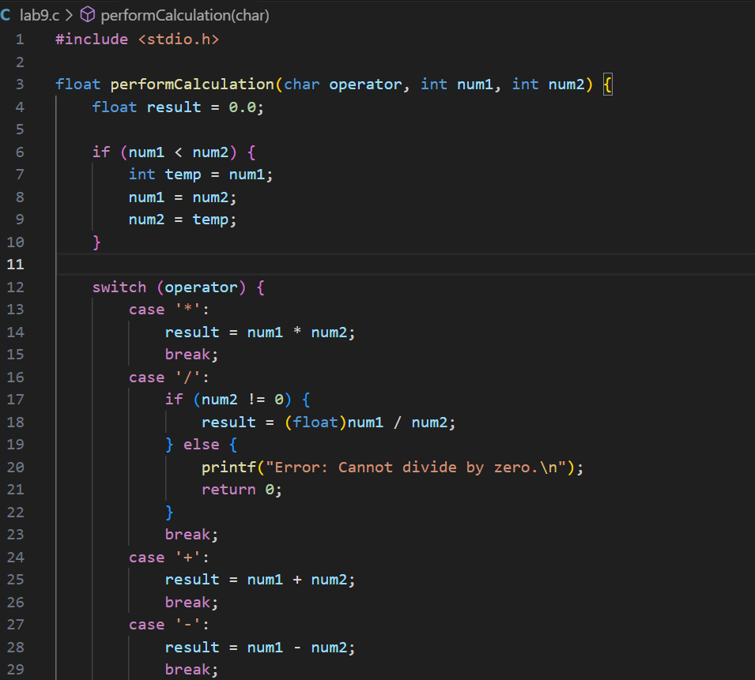

**Q5:**

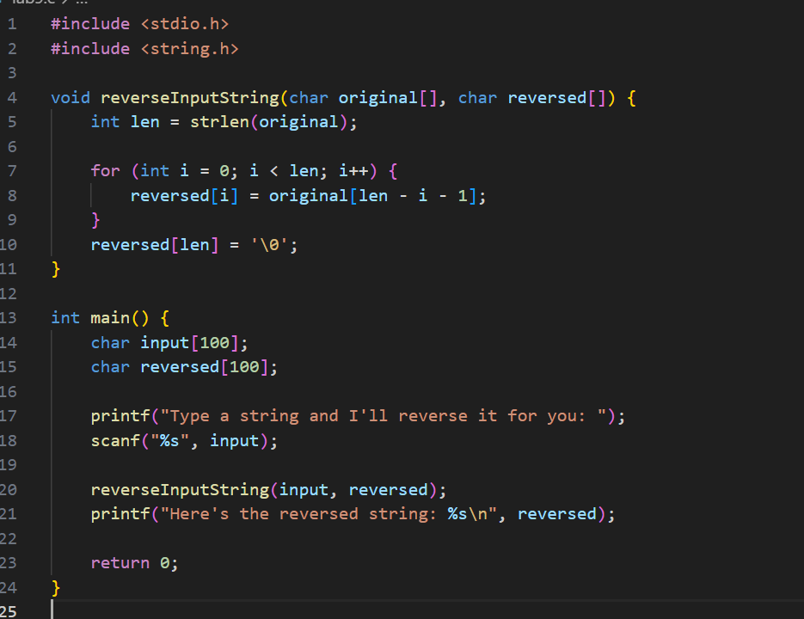

**Q6:**

